rem与mod的区别

# rem函数：Remainder after division

R = rem(X,Y) returns the remainder after division of X by Y. In general, if Y does not equal 0, R = rem(X,Y) returns X - n.*Y, where n = fix(X./Y). If Y is not an integer and the quotient X./Y is within roundoff error of an integer, then n is that integer. Inputs X and Y must have the same dimensions unless one of them is a scalar double. If one of the inputs has an integer data type, then the other input must be of the same integer data type or be a scalar double.

The following are true by convention:

**rem(X,0) is NaN.**

**rem(X,X) for X~=0 is 0.**

**rem(X,Y) for X~=Y and Y~=0 has the same sign as X.**

示例：

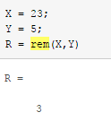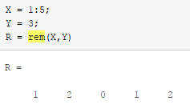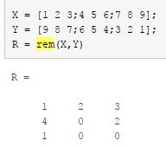

**rem(x,0)是NaN.**

**rem(x,x), 当 x~=0, 是 0.**

**rem(x,y), 当 x~=y 和 y~=0时, 与 x同号.**

# mod函数: Remainder after division (modulo operation)

b = mod(a,m) returns the remainder after division of a by m, where a is the dividend and m is the divisor. This function is often called the modulo operation and is computed using b = a - a.*floor(a./m). **The mod function follows the convention that mod(a,0) returns a.**

**mod(x,0) 是 x.**

**mod(x,x) 是 0.**

**mod(x,y), 当 x~=y 和 y~=0时, 与 y同号.**

# Difference Between rem and mod

Define X and Y with different signs

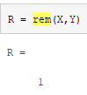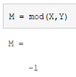

MATLAB文档中介绍：rem(X,Y) and mod(X,Y) are equal **if X and Y have the same sign**, but differ by Y **if X and Y have different signs**. Notice that **rem retains the sign of X,** **while mod retains the sign of Y.** 如果X和Y同号，则rem与mod等价；否则，不相同。rem的结果与X符号相同，mod的符号与Y相同。

## 符号上的区别

rem(x,y)与mod(x,y)的区别：

当x,y同号时，rem与mod结果相同；

当x,y异号时，rem(x,y)与x同号，mod(x,y)与y同号。

## 算法上的区别

**rem(x,0)是NaN.**

**rem(x,x), 当 x~=0, 是 0.**

**rem(x,y), 当 x~=y 和 y~=0时, 与 x同号.**

而 **mod(x,0) 是 x.**

**mod(x,x) 是 0.**

**mod(x,y), 当 x~=y 和 y~=0时, 与 y同号.**